Curvature

Definition
# Source: AI Source: Provided by: [Data Path: Persons Table -> ID Column: 1, Name_En Column: Motasem Essam] -> From: [ChatGPT] on [7/25/2026]
Curvature is a geometric quantity that measures how rapidly a curve changes direction as one moves along it.
A straight line has zero curvature because its direction does not change. A curve that bends sharply has greater curvature than a curve that bends gently.
Curvature = A measure of the rate at which a curve changes direction along its length.
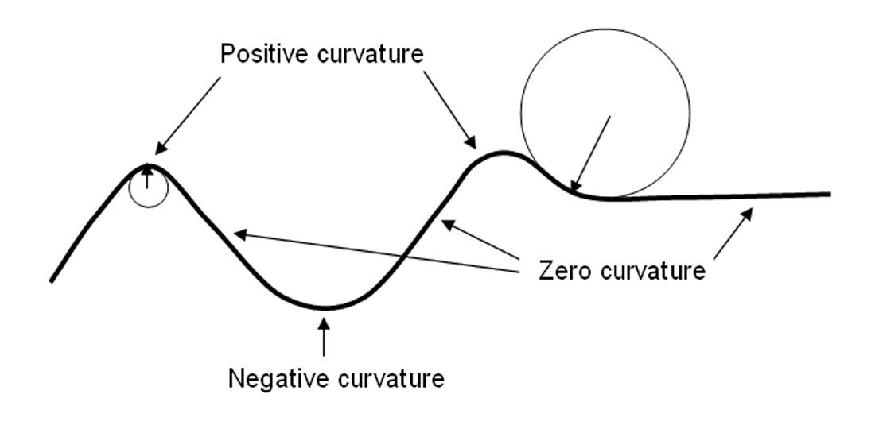
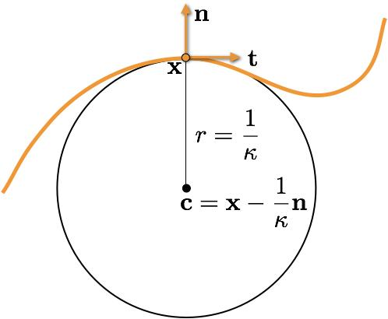
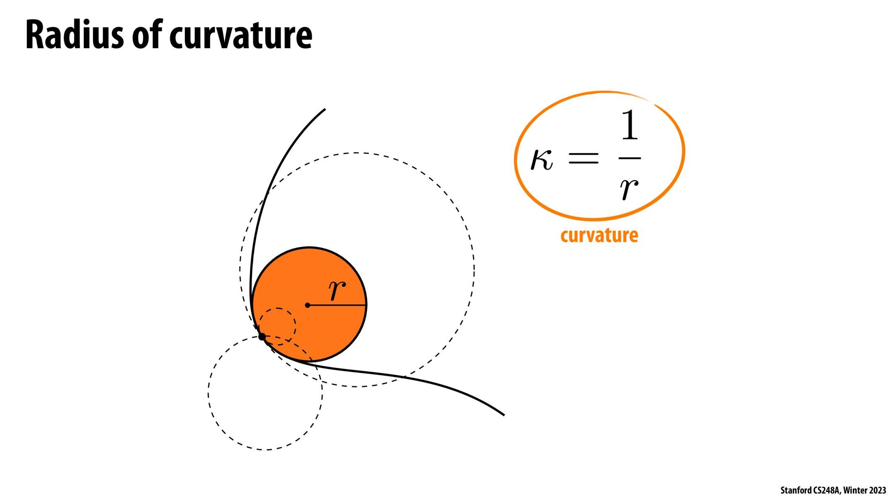

Fundamental Concept
# Source: AI Source: Provided by: [Data Path: Persons Table -> ID Column: 1, Name_En Column: Motasem Essam] -> From: [ChatGPT] on [7/25/2026]
Curvature describes how quickly the direction of a curve changes as we travel along it.
For a smooth curve, curvature at a point can be defined as
$$\boxed{κ=\left\|\frac{dT}{ds}\right\|}$$
where:
- $κ$ is the curvature.
- $T$ is the unit tangent vector.
- $s$ is the arc length along the curve.
The curvature measures the rate of change of the unit tangent vector per unit arc length.

Basic Structure
# Source: AI Source: Provided by: [Data Path: Persons Table -> ID Column: 1, Name_En Column: Motasem Essam] -> From: [ChatGPT] on [7/25/2026]
Geometry
└── Differential Geometry
└── Curves and Surfaces
└── Curvature
├── Curve Curvature
├── Radius of Curvature
├── Signed Curvature
├── Normal Curvature
└── Principal Curvatures
This is a useful organizational hierarchy. Curvature of curves and curvature of surfaces are related but distinct topics in differential geometry.

Main Types and Related Concepts
# Source: AI Source: Provided by: [Data Path: Persons Table -> ID Column: 1, Name_En Column: Motasem Essam] -> From: [ChatGPT] on [7/25/2026]
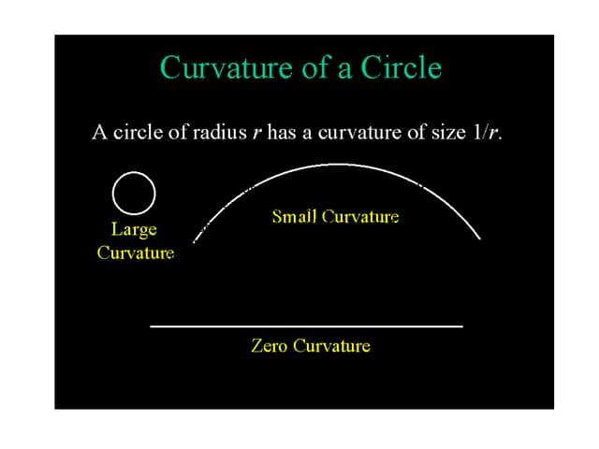

1. Curve Curvature
# Source: AI Source: Provided by: [Data Path: Persons Table -> ID Column: 1, Name_En Column: Motasem Essam] -> From: [ChatGPT] on [7/25/2026]
Measures the bending of a curve at a particular point.
For a circle of radius $R$:
$$\boxed{κ=\frac{1}{R}}$$
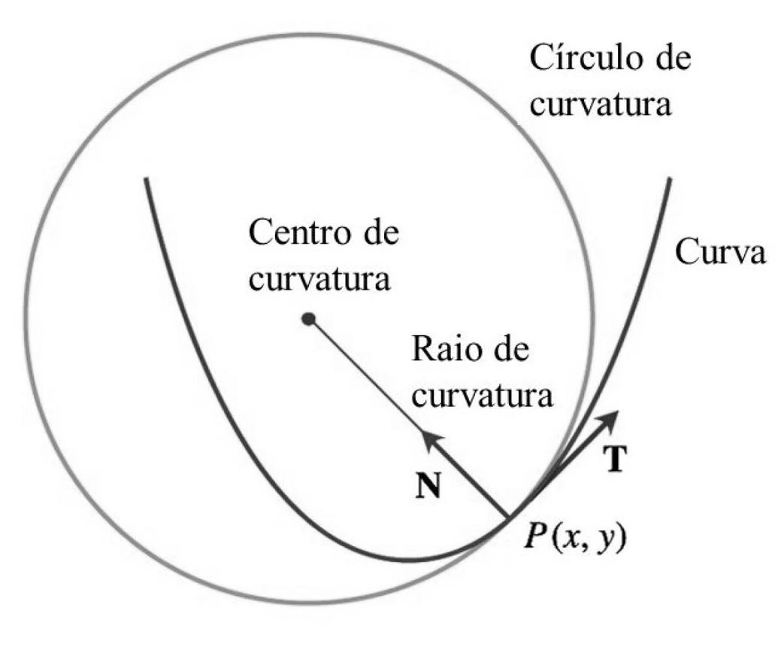

2. Radius of Curvature
# Source: AI Source: Provided by: [Data Path: Persons Table -> ID Column: 1, Name_En Column: Motasem Essam] -> From: [ChatGPT] on [7/25/2026]
The reciprocal of the curvature when the curvature is nonzero:
$$\boxed{ρ=\frac{1}{κ}}$$
A large radius means gentle bending; a small radius means sharp bending.
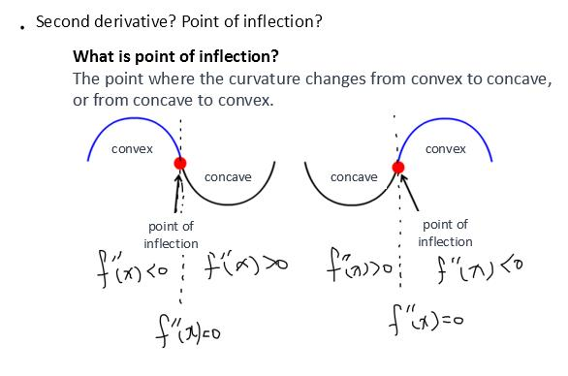

3. Signed Curvature
# Source: AI Source: Provided by: [Data Path: Persons Table -> ID Column: 1, Name_En Column: Motasem Essam] -> From: [ChatGPT] on [7/25/2026]
In a plane, signed curvature records both the magnitude of bending and its direction relative to a chosen orientation. Its sign convention depends on how the curve is oriented.
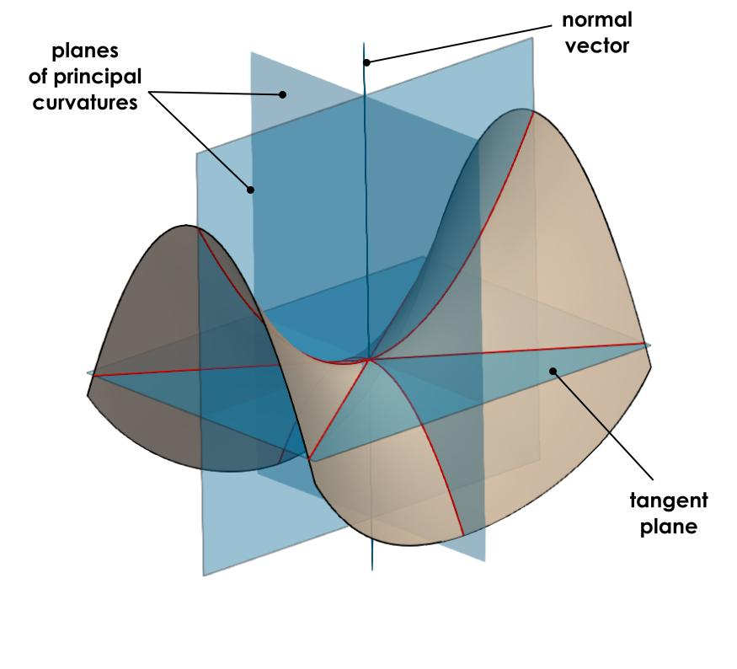

4. Surface Curvature
# Source: AI Source: Provided by: [Data Path: Persons Table -> ID Column: 1, Name_En Column: Motasem Essam] -> From: [ChatGPT] on [7/25/2026]
Describes how a surface bends in different directions. Important concepts include normal curvature and the two principal curvatures.

Mathematical Representation

1. Curvature of a Plane Curve
# Source: AI Source: Provided by: [Data Path: Persons Table -> ID Column: 1, Name_En Column: Motasem Essam] -> From: [ChatGPT] on [7/25/2026]
For a curve represented as $y=f\left(x\right)$, its curvature is
$$\boxed{κ=\frac{\left|y''\right|}{{\left(1+{\left(y'\right)}^{2}\right)}^{3/2}}}$$
where $y'$ and $y''$ are the first and second derivatives with respect to $x$.

2. Curvature of a Parametric Curve
# Source: AI Source: Provided by: [Data Path: Persons Table -> ID Column: 1, Name_En Column: Motasem Essam] -> From: [ChatGPT] on [7/25/2026]
For a plane curve given by $x=x\left(t\right)$ and $y=y\left(t\right)$,
$$\boxed{κ=\frac{\left|x'y''-y'x''\right|}{{\left({\left(x'\right)}^{2}+{\left(y'\right)}^{2}\right)}^{3/2}}}$$
provided the curve has a nonzero velocity vector.

3. Curvature of a Circle
# Source: AI Source: Provided by: [Data Path: Persons Table -> ID Column: 1, Name_En Column: Motasem Essam] -> From: [ChatGPT] on [7/25/2026]
For a circle with radius $R$,
$$\boxed{κ=\frac{1}{R}}$$
For example, a circle of radius $2$ units has curvature
$$κ=\frac{1}{2}$$
while a circle of radius $5$ units has curvature
$$κ=\frac{1}{5}$$
Therefore, the smaller circle has greater curvature.

Curvature vs. Radius of Curvature
# Source: AI Source: Provided by: [Data Path: Persons Table -> ID Column: 1, Name_En Column: Motasem Essam] -> From: [ChatGPT] on [7/25/2026]
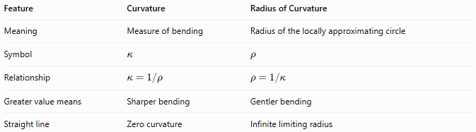
Feature | Curvature | Radius of Curvature
Meaning | Measure of bending | Radius of the locally approximating circle
Symbol | $$κ$$ | $$ρ$$
Relationship | $$κ=1/ρ$$ | $$ρ=1/κ$$
Greater value means | Sharper bending | Gentler bending
Straight line | Zero curvature | Infinite limiting radius

Applications
# Source: AI Source: Provided by: [Data Path: Persons Table -> ID Column: 1, Name_En Column: Motasem Essam] -> From: [ChatGPT] on [7/25/2026]
- Road and Railway Design: Controlling bends and turning radii.
- Architecture: Designing curved structures and surfaces.
- Robotics: Planning smooth motion and trajectories.
- Computer Graphics: Modeling and smoothing curves and surfaces.
- Physics: Describing the bending of paths and the motion of objects along curved trajectories.
- Differential Geometry: Studying the local and global properties of curves and surfaces.

Key Points
# Source: AI Source: Provided by: [Data Path: Persons Table -> ID Column: 1, Name_En Column: Motasem Essam] -> From: [ChatGPT] on [7/25/2026]
- Curvature measures how rapidly a curve changes direction along its length.
- A straight line has zero curvature.
- A circle has constant curvature equal to the reciprocal of its radius.
- The radius of curvature is the reciprocal of nonzero curvature.
- Signed curvature also describes the direction of bending in an oriented plane curve.
- Surface curvature includes concepts such as normal and principal curvature.

Conclusion
# Source: AI Source: Provided by: [Data Path: Persons Table -> ID Column: 1, Name_En Column: Motasem Essam] -> From: [ChatGPT] on [7/25/2026]
Curvature is a fundamental concept in differential geometry that measures the bending of curves and surfaces. It connects the local shape of a geometric object with its tangent directions, normal directions, and radius of curvature. It is essential for understanding geometric shape, smoothness, and the behavior of curved paths.

